Thank you for your interest in INSTRuCT data.
Please send your completed proposal and any questions to Suzi Birz suzi@uchicago.edu

Date
Proposal Title
Principal Investigator
Institution
Cooperative Group | - COG  - CWS  - EpSSG  - Not a member of one of these Cooperative Groups
E-mail Address
Co-authors
Statistician name
Statistician e-mail
Statistician institution
Statistician Affiliation | - COG  - CWS  - EpSSG  - Not a member of one of these Cooperative Groups - CV attached  - If you would like to perform the analysis locally, in lieu of using a statistician or data manager from COG, CWS, or EpSSG, please include the CV of your statistician and provide a detailed statistical plan.
Project Timeline | All investigators requesting data should ensure that the project is completed within a reasonable timeframe. Every effort should be made to meet the time points outlined below:  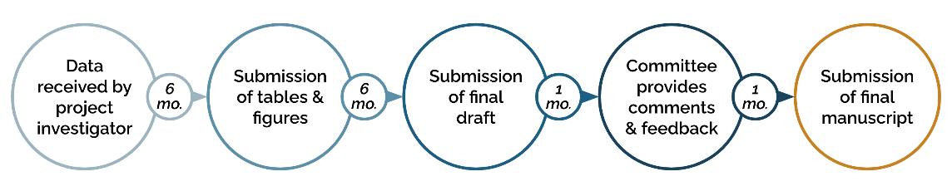
If you foresee challenges in adhering to this timeline, please describe

Data Portal Pilot | Did you utilize the PCDC Data Portal Cohort Explorer Tool to determine study feasibility or sample size for this project?  - Yes  - No
Did you utilize the PCDC Data Portal Kaplan-Meier Survival Analysis Tool for early hypothesis exploration for this project?
- Yes
- No
If you utilized the Kaplan-Meier Survival Analysis Tool, have you attached the relevant entries from your personal hypothesis record along with the project request?
- Yes - attached
- No - not applicable

Please format your project proposal as follows:
Please limit your request to 5 pages

- Specific Aims
- Hypothesis
- Patient Cohort (Eligibility Criteria)
- Background
- Significance
- Proposal description
- Data Requested [please refer to the data dictionary to define the specific data elements requested.]

